# Enable Multichain Service in your global account for Canary

## Preparation:

Log on to your SAP Cloud Foundry Global Account. If you do not have a global account create a new one using the Internal Stakeholder Tool (ISM) <https://ism.int.sap.hana.ondemand.com/> as described in the Cloud Foundry Jam page, 1b: <https://jam4.sapjam.com/groups/ApFhQ0NCGAzAtXQWsdqB3B/overview_page/p8JIXj2pstIcY7TegLyOp8>  
While creating a new global account it is important to enable at least 1 application runtime for Cloud Foundry. If not, you will get a NEO-only account that is not Cloud Foundry-ready.

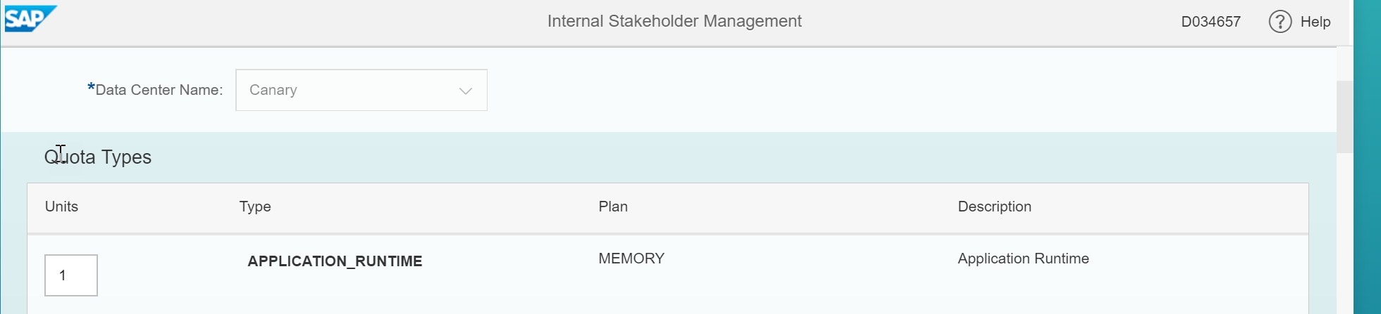

If you want to re-use an existing NEO account and enable it for Cloud Foundry, you have to open a jtrack ticket on component CIS-ISM tool.

## Enable Multichain in your global account:

To use the Multichain service in your global account you must enable quota units and assign them to your respective subaccounts.

Start with the Internal Stakeholder Management tool <https://ism.int.sap.hana.ondemand.com>

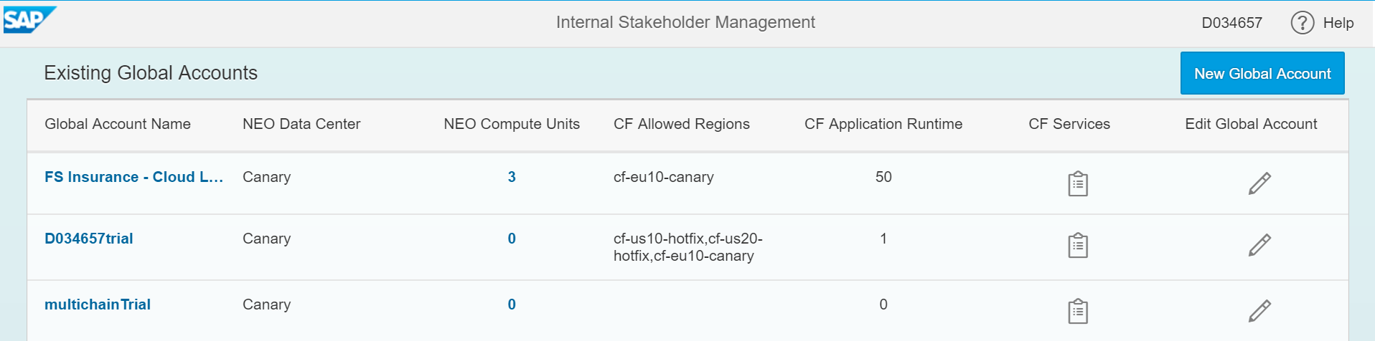

If you don’t see you global account, you may not have admin rights in your global account. Please get in contact with the administrator to let him enabling Multichain quotas.

Click on Edit Global account and scroll down to multichain.

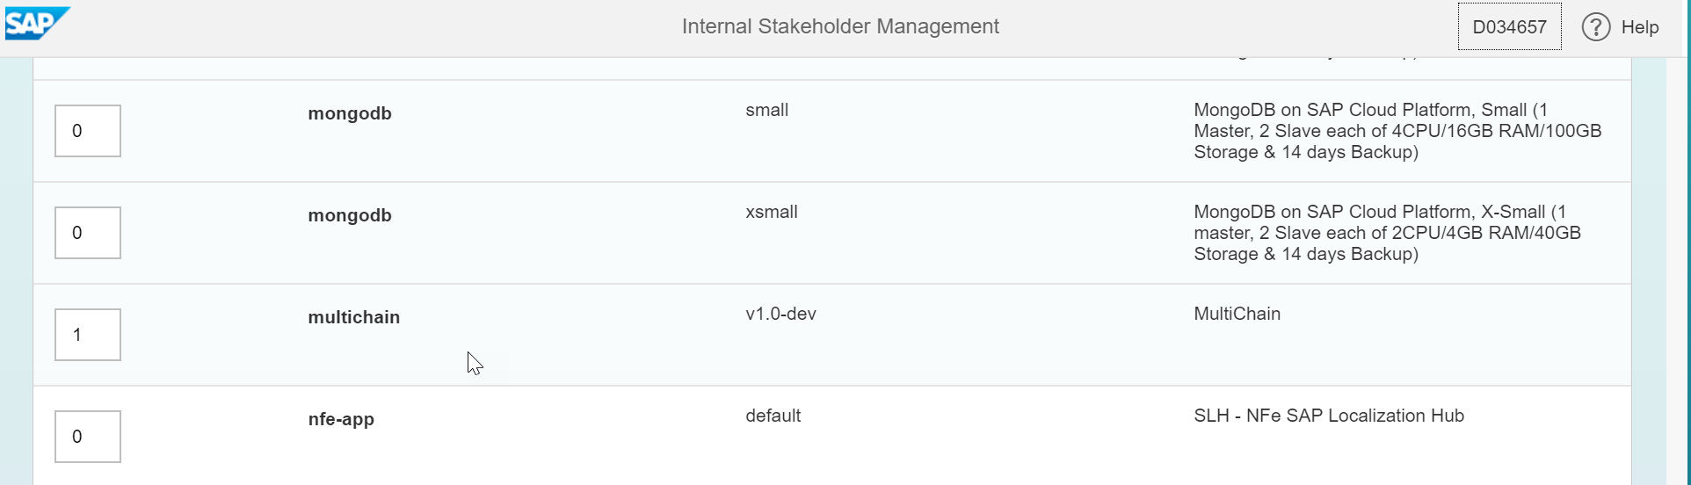

Enter the amount of units you may use in this global account. We expect that each global account will setup 3-5 nodes only, so take the value of 5 if you do not yet know it better. This will allow your global account to use up to 5 multichain instances. Click SAVE.

In the Internal Stakeholder Management Tool you have simulated purchasing the multichain services up to the amount of units. To make use of them in your individual subaccounts, you have to manage the entitlements in your global account. To do so log-on to your global account:

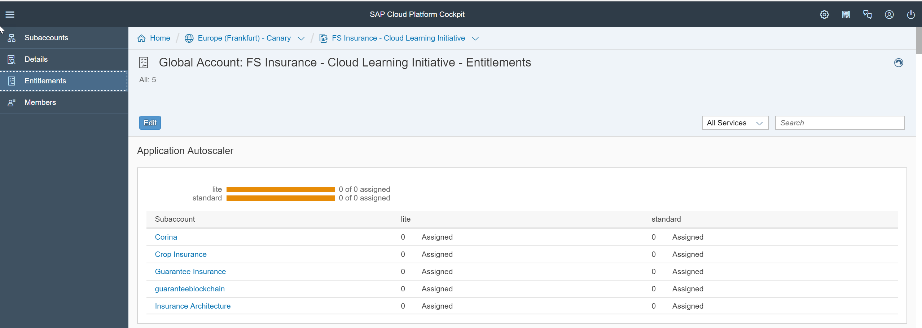

Click on EDIT and scroll down to multichain.

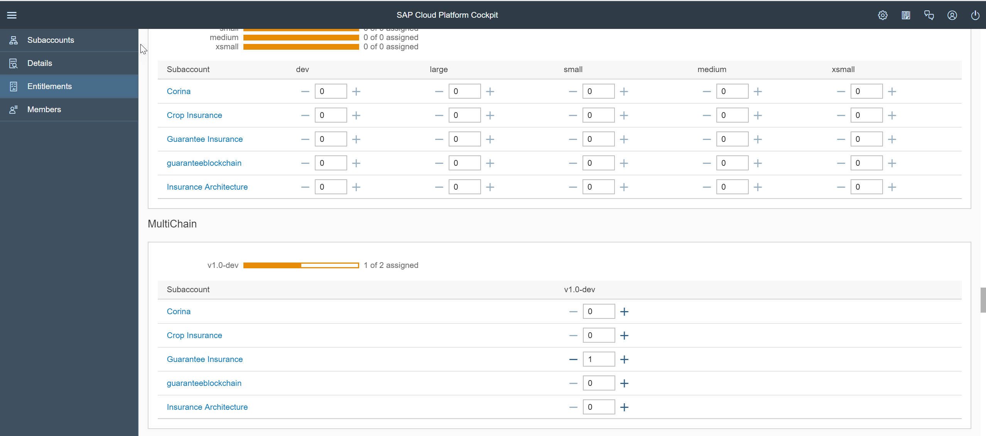

You can now assign units to your subaccounts up to the amount of quota you have “purchased” in the Internal Stakeholder Management Tool.

Scroll back to the top and click SAVE.

You can now use the multichain service in the respective subaccounts of your global account.  
If you want to have some tutorials, proceed with the Hands-On documents on MaaS Jam Subgroup of the Blockchain Jam: <https://jam4.sapjam.com/groups/5yjoVnClxw91MBszN8mO6c/overview_page/GuhOBeBZTA2VuXNJ3baIex>